**Assignment 1**

**Title: Software Introduction**

**Submitted By: Shivraj Ashok Futane  
URN: 2024-B-30082006A  
Semester: II  
Program: BCA**

**Course:  Data Base Management System**

Lab Objective: Students will be able to know DBMS software.

Prerequisites:

The prerequisites for this lab are knowledge of sessions 1-2 and the following:

● RDBMS Software

● Hardware like Desktop/Laptop to support the software Outcome: Students will be able to understand the software/tool that needs to be installed on the computer/laptop.

Description:

● Database Management System

■ This model is like a hierarchical tree structure used to construct a hierarchy of records in the form of nodes and branches. The data elements present in the structure have a Parent-Child relationship. Closely related information in the parent-child structure is stored together as a logical unit. A parent unit may have many child units, but a child is restricted to having only one parent.

■ The drawbacks of this model are: ○ The hierarchical structure is not exible to represent all the relationship proportions, which occur in the real world. ○ It cannot demonstrate the overall data model for the enterprise because of the non-availability of actual data at the time of designing the data model. ○ It cannot represent the Many-to-Many relationship.

■ Network Model ○ It supports the One-To-One and One-To-Many types only. The basic objects in this model are Data Items, Data Aggregates, Records, and Sets. ○ It is an improvement on the Hierarchical Model. Here multiple parent-child relationships are used. Rapid and easy access to data is possible in this model due to multiple access paths to the data elements.

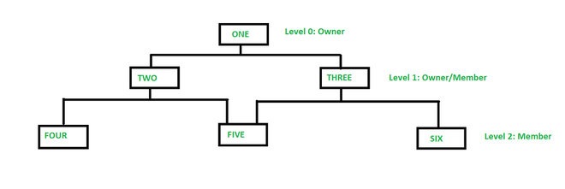

■ Relational Model ○ Does not maintain the physical connection between relations Data is organized in terms of rows and columns in a table. ○ The position of a row and/or column in a table is of no importance. ○ The intersection of a row and column must give a single value.

■ Features of an RDBMS ○ The ability to create multiple relations and enter data into them. ○ An attractive query language.

○ Retrieval of information stored in more than one table. ○ An RDBMS product has to satisfy at least seven of the 12 rules of Codd to be accepted as a full-edged RDBMS.

● Relational Database Management System

■ RDBMS is an acronym for Relational Database Management System. Dr. E. F. Codd rst introduced the relational database model in 1970. The relational model allows data to be represented in a simple row or column. Each data eld is considered a column, and each record is considered a row. A relational database is more or less similar to a database management system. In a relational model, there is a relationship between the data elements. The data is stored in tables. Tables have columns, rows, and names. Tables can be related to each other if each has a column with a common type of information. The most famous RDBMS packages are Oracle, Sybase, and Informix.

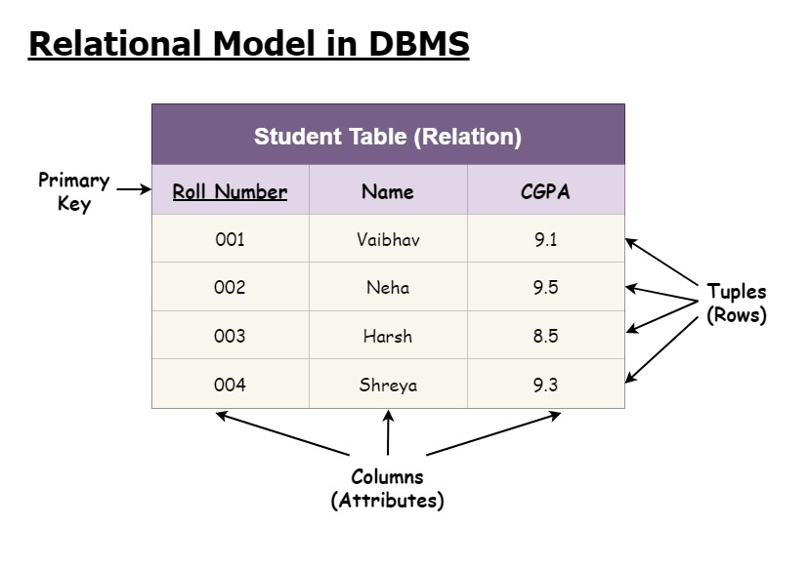

A simple example of a relational model is the following:

■ Student Details Table Here, both tables are based on students' details. The common eld in both tables is Rollno. So we can say both tables are related to each other through the Rollno column.

■ Degree of Relationship

○ One to One (1:1) ○ One to Many or Many to One (1:M / M: 1)

○ Many to Many (M: M) The degree of relationship indicates the link between two entities for a specied occurrence of each.

○ One-to-One Relationship: (1:1) Student Has to Roll No. ➢ One student has only one Rollno. For one occurrence of the rst entity, there can be, at the most one related occurrence of the second entity, and vice-versa.

○ One-to-Many or Many-to-One Relationship: (1:M/M:1) Course Contains Students

➢ As per the Institution's Norm, One student can enroll in one course at a time however, in one course, there can be more than one student.

➢ For one occurrence of the rst entity, there can be many related occurrences of the second entity, and for every occurrence of the second entity, there is only one associated occurrence of the rst.

○ Many to Many Relationship: (M: M) Students Appear Tests

➢ The major disadvantage of the relational model is that a clear-cut interface cannot be determined. The reusability of a structure is not possible. The Relational Database is now an accepted model on which major database systems are built.

➢ Oracle has introduced added functionality to this by incorporating object-oriented capabilities. Now it is known as Object-Relational Database Management System (ORDBMS). The object-oriented concept is added in Oracle8.

➢ Some basic rules have to be followed for a DBMS to be relational. They are known as Codd’s rules, designed in such a way that when the database is ready for use it encapsulates the relational theory to its full potential. These twelve rules are as follows.

● E. F. Codd Rules

■ The Information Rule ○ All information must be stored in the table as data values.

■ The Rule of Guaranteed Access ○ Every item in a table must be logically addressable with the help of a table name

■ The Systematic Treatment of Null Values ○ The RDBMS must take care of null values to represent missing or inapplicable information.

■ The Database Description Rule ○ A description of the database is maintained using the same logical structures with which data is dened by the RDBMS.

■ Comprehensive Data Sub-Language ○ According to the rule, the system must support data denition, view denition, data manipulation, integrity constraints, authorization, and transaction management operations.

■ The View Updating Rule ○ All views that are theoretically updatable are also updatable by the system.

■ The Insert and Update Rule ○ This rule indicates that all the data manipulation commands must be operational on sets of rows having a relation rather than on a single row.

■ The Physical Independence Rule

○ Application programs must remain unimpaired when any changes are made in storage representation or access methods.

■ The Logical Data Independence Rule ○ The changes that are made should not affect the user’s ability to work with the data. The change can be splitting the table into many more tables.

■ The Integrity Independence Rule ○ The integrity constraints should be stored in the system catalog or the database.

■ The Distribution Rule ○ The system must access or manipulate the data that is distributed in other systems.

■ The Non-subversion Rule ○ If an RDBMS supports a lower-level language then it should not bypass any integrity constraints dened at the higher level.

Object-Relational Database Management System

■ Oracle8 and later versions are supported object-oriented concepts. A structure once created can be reused is the fundamental of the OOP’s concept. So we can say Oracle8 has supported the Object-Relational model, and Object-oriented model both. Oracle products are based on a concept known as client-server technology. This concept involves segregating the processing of an application between two systems.

■ One performs all activities related to the database (server).

■ The other performs activities that help the user to interact with the application (client).

■ A client or front-end database application also interacts with the database by requesting and receiving information from the database server. It acts as an interface between the user and the database.

■ The database server, or back end, is used to manage the database tables and also respond to client requests.

● Introduction to ORACLE

■ ORACLE is a powerful RDBMS product that provides efcient and effective solutions for major database features. This includes

○ Large Databases and Space

○ Management Controls many Concurrent

○ Database Users ○ High Transaction Processing

○ Performance High Availability

○ Controlled Availability

○ Industry Accepted Standards

○ Manageable Security

○ Database Enforced Integrity Client/Server Environment

○ Distributed Database Systems

○ Portability

○ Compatibility

○ Connectivity

An ORACLE database system can easily take advantage of distributed processing by using its client-server architecture. In this architecture, the database system is divided into two parts:

1. Front-End or Client Portion ○ The client executes the database application that accesses database information and interacts with the user.

2. Back-End or Server Portion ○ The server executes the ORACLE software and handles the functions required for concurrent, shared data access to the ORACLE database.

● Problem Statement for “ROADWAY TRAVELS”

■ “Roadway Travels” has been in business since 1977 with several buses connecting different places in India.

■ Its main ofce is located in Gurugram. The company wants to computerize its operations in the following areas:

■ Reservations

■ Ticketing

■ Cancellations

● Reservations:

○ Reservations are directly handled by the booking ofce. reservations can be made 60 days in advance in either cash or credit. In case the ticket is not available, a wait-listed ticket is issued to the customer. This ticket is conrmed against the cancellation.

● Cancellation and modication:

○ Cancellations are also directly handed in at the booking ofce. Cancellation charges will be charged. Wait-listed tickets that do not get conrmed are fully refunded.